School Name
Mathematics Test 2017
Year 10 | Geometric Reasoning | Non Calculator
Skills and Knowledge Assessed:  - Apply logical reasoning, including the use of congruence and similarity, to proofs and numerical exercises involving plane shapes (ACMMG244)  - Formulate proofs involving congruent triangles and angle properties (ACMMG243) |  | Name_________________
Extended Answer Test
Answers should be supported by relevant mathematical reasoning and/or calculations
Full marks may not be awarded for answers with no reasoning.
Complete any diagrams and write all working and answers in the spaces provided on this test paper.
 |  | Marks
 | 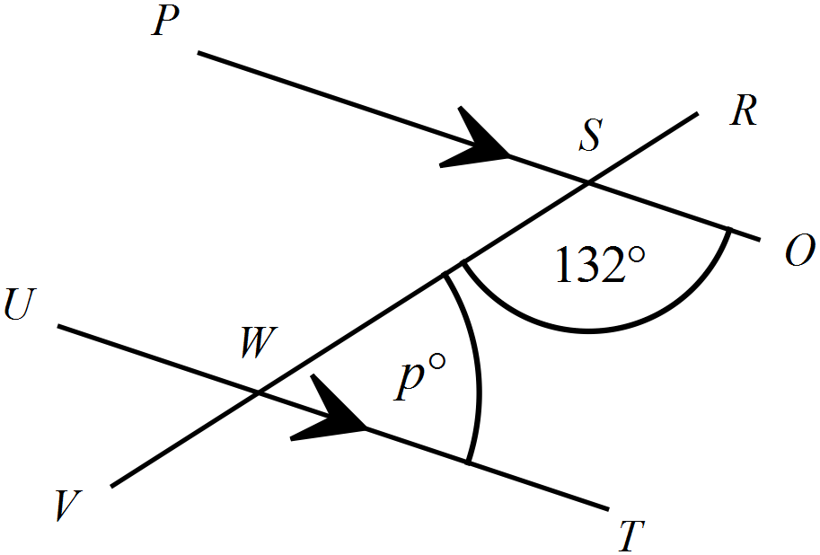(a) Find the value of p.  …………………………………………  ………………………………………….  …………………………………………  ..………………………………………. | 2
 | (b) Find the value of x.  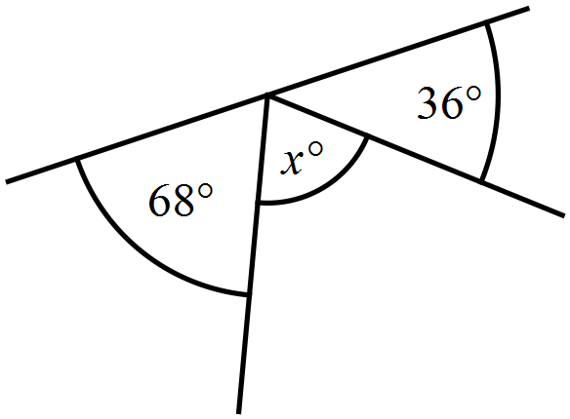  …………………………………………  ………………………………………….  …………………………………………  ..………………………………………. | 2
 | 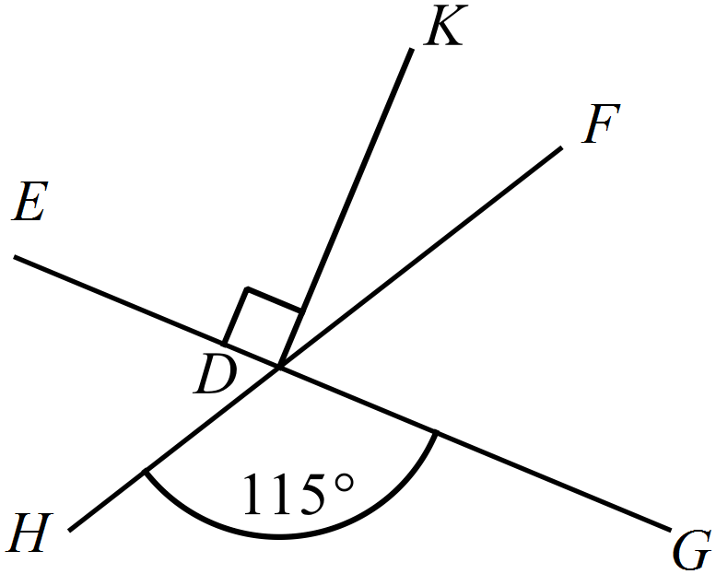(c) Find the size of 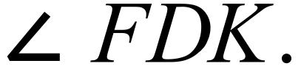  ……………………………………………  ….………………………………………..  ……………………………………………  ……..…………………………………….. | 2
 | 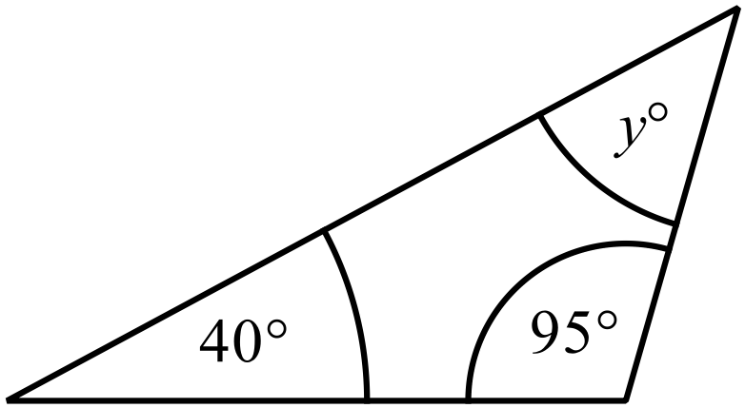(a) Find the value of y.  ……………………………………………  ….………………………………………..  ……………………………………………  ……..…………………………………….. | 2
 | (b) Find the value of d.  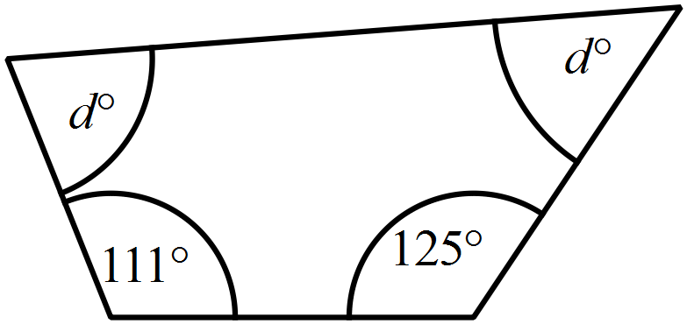  …………………………………………  ………………………………………….  …………………………………………  ..……………………………………..…. | 2
 | 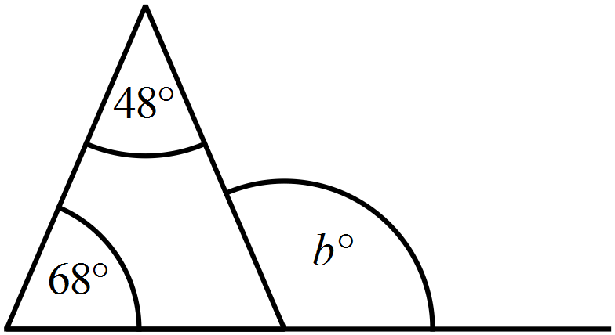(c) Find the value of b.  …………………………………………  ………………………………………….  …………………………………………  ..………………………………………. | 2
 | 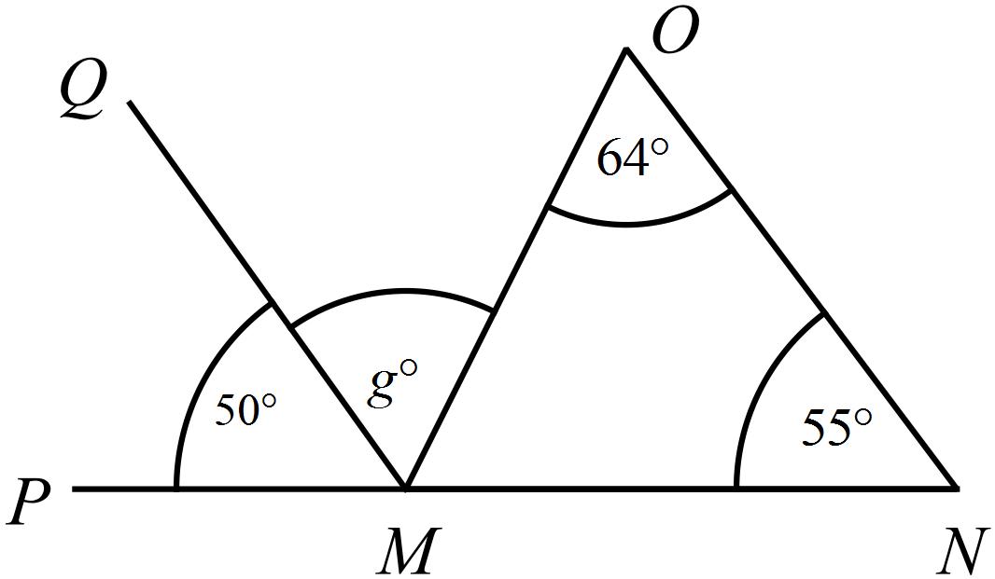(a) Find the value of g.  ………………………………………………  ……………………………………………….  ………………………………………………  ………………………………………………. | 3
 | (b) ABCD is a parallelogram.  F is a point on AB such that 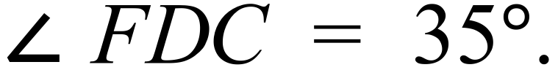  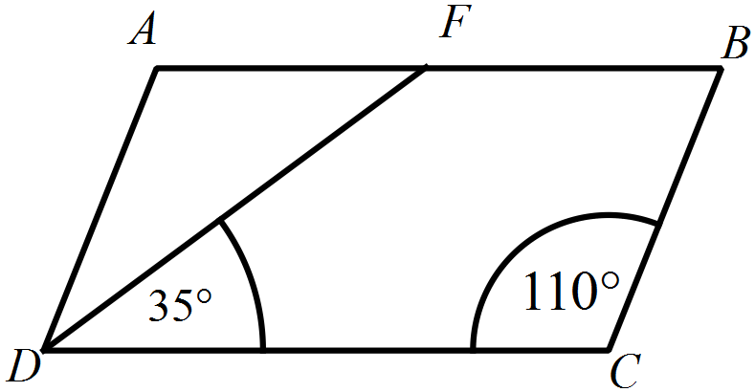Find the size of 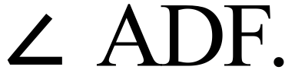  ………………………………………………  ……………………………………………….  ………………………………………………  ………………………………………………. | 3
 | (c) PQR is an isosceles triangle. PR is produced to S.  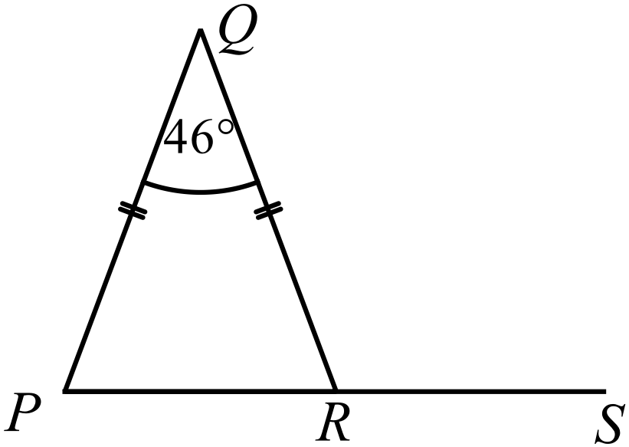 Find the size of 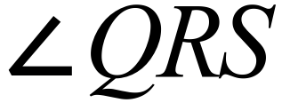.  ………………………………………………  ……………………………………………….  ………………………………………………  ………………………………………………. | 3
4. | 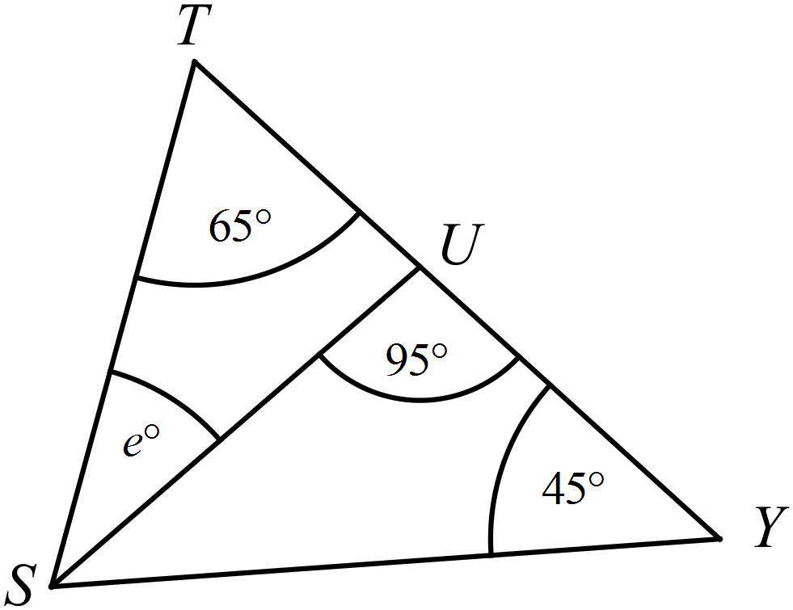(a)  U is a point on TY such that 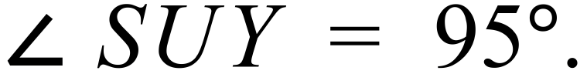  Find the value of e.  …………………………………………  ………………………………………….  …………………………………………  ..………………………………………. | 3
 | (b) In the diagram, 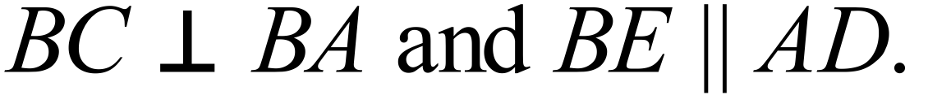  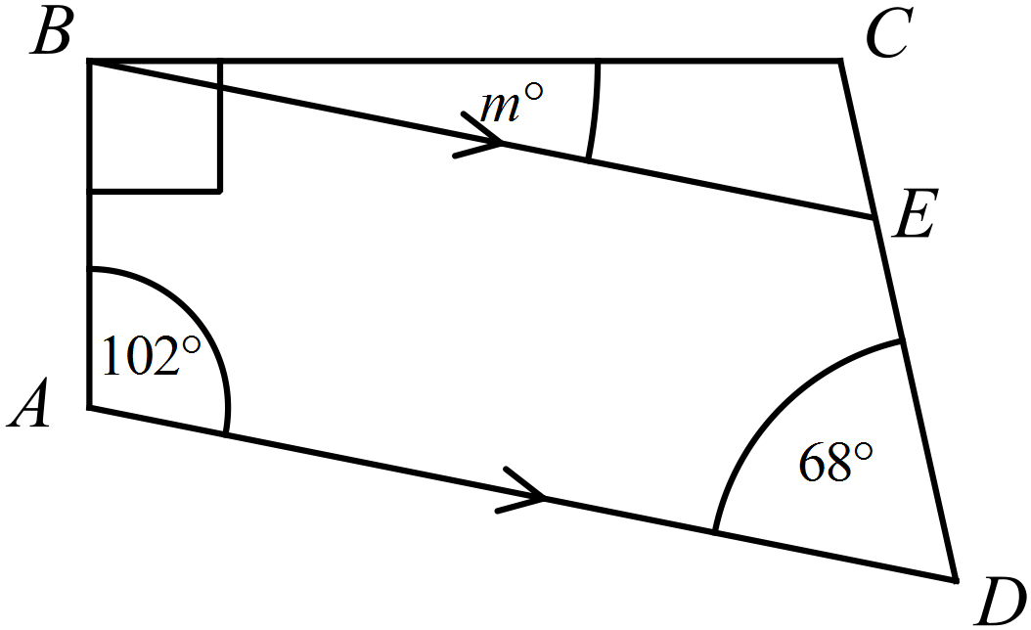 Find the value of m.  ………………………………………………  ……………………………………………….  ………………………………………………  ………………………………………………. | 3
 | (c) Find the value of   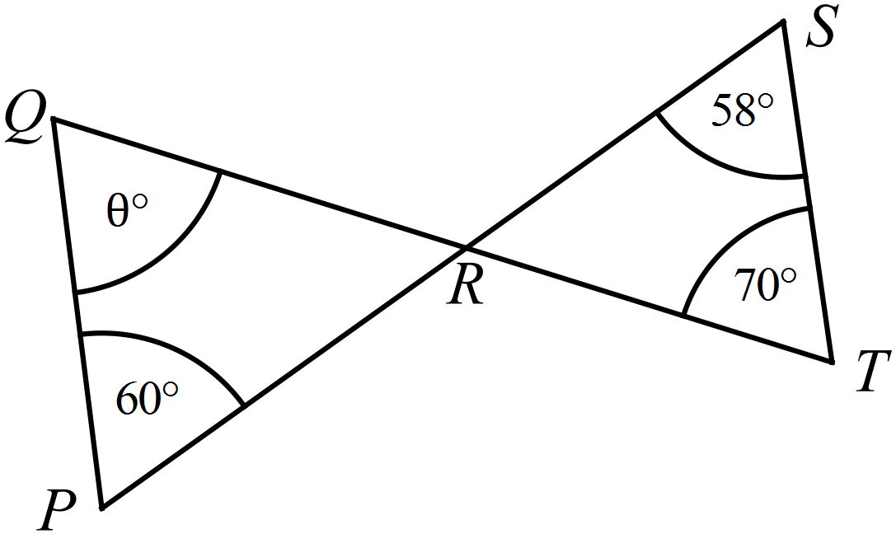  ………………………………………………  ……………………………………………….  ………………………………………………  ………………………………………………. | 3
5. | (a)  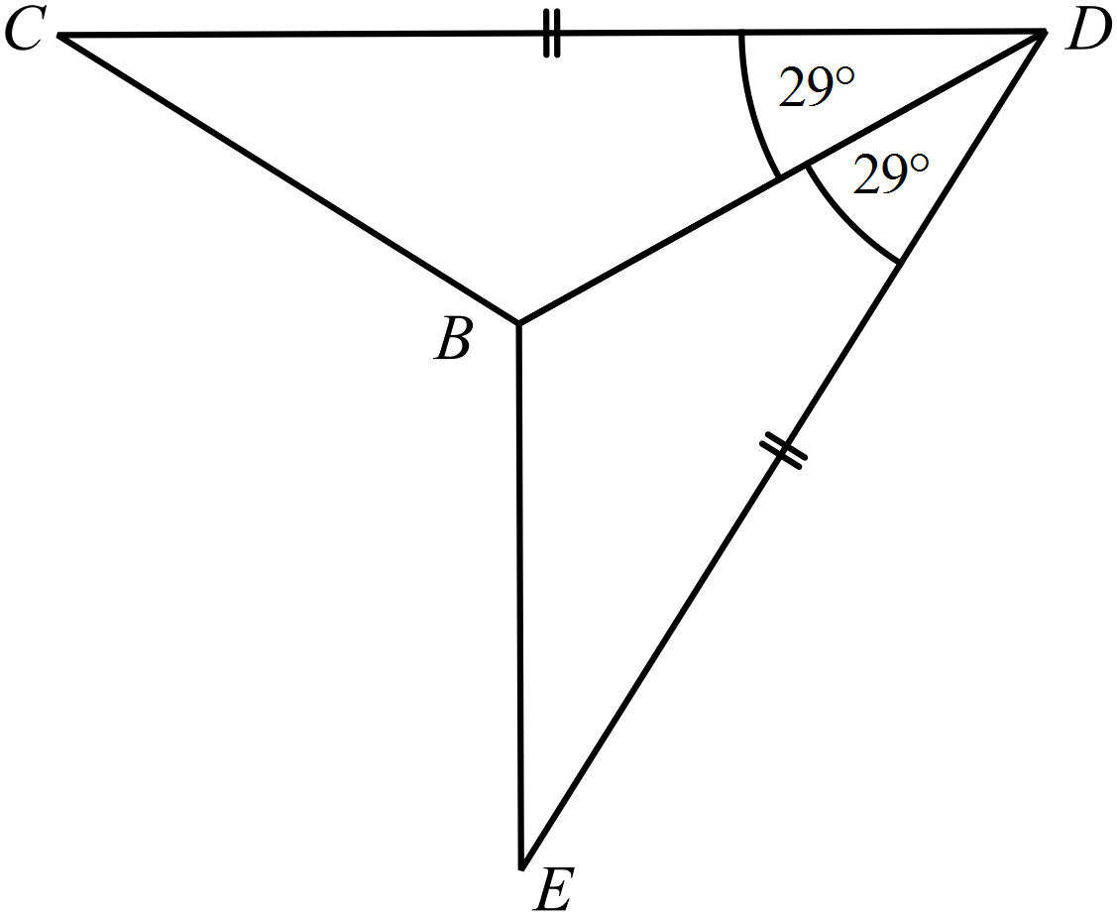  ……………………………………………………………………………………  ……………………………………………....……………………………………  ……………………………………………………………………………………  ……………………………………………….…………………………………… | 3
 | (b) EF and GH are two line segments which bisect one another at right angles at O  FH and EG are joined to create 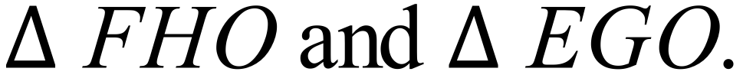  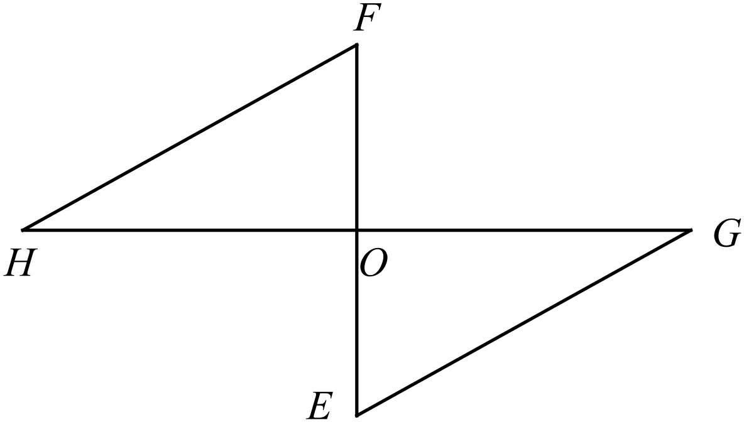  - Prove that  ……………………………………………………………………………………  ……………………………………………………………………………………  ……………………………………………....……………………………………  ……………………………………………………………………………………  - FG and HE are joined to form the quadrilateral FGEH.  List two other pairs of congruent triangles apart from the pair in part (i).  ……………………………………………………………………………………  ……………………………………………………………………………………  - What type of quadrilateral is FGEH? Give reasons for your choice.  ……………………………………………....……………………………………  …………………………………………………………………………………… | 2  2  2
 | (c) The diagram below shows a regular octagon with three diameters draw inside it.  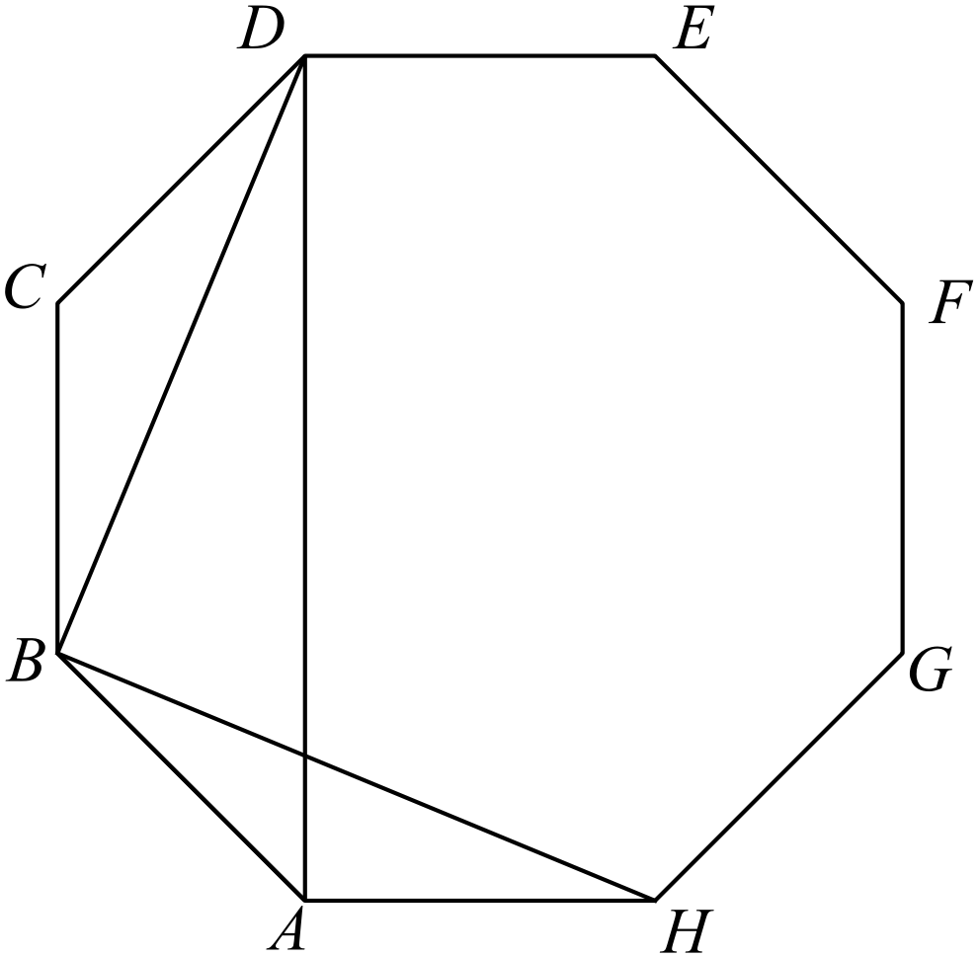  - Show that 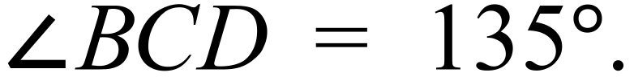  ……………………………………………....……………………………………  ……………………………………………………………………………………  - Show that 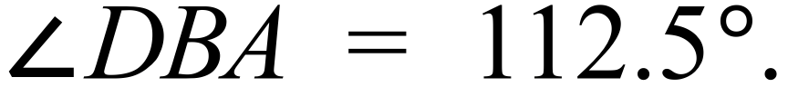  ……………………………………………………………………………………  ……………………………………………....……………………………………  ……………………………………………………………………………………  - Show that 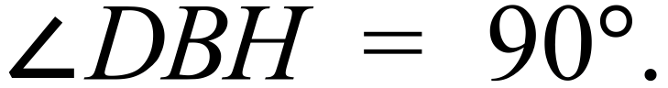  ……………………………………………………………………………………  ……………………………………………....……………………………………  …………………………………………………………………………………… | 2  2  2
6. | (a)  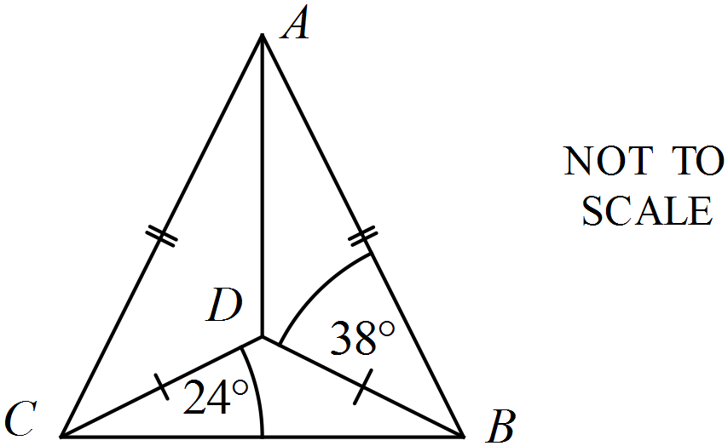  ……………………………………………………………………………………  ……………………………………………....……………………………………  ……………………………………………………………………………………  ……………………………………………….…………………………………… | 3
 | (b) In the diagram below BC || DE, AB = 15 cm, BD = 18 cm and BC = 10 cm.  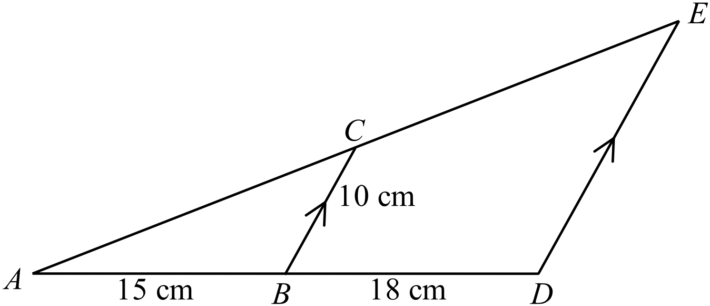  - Prove that 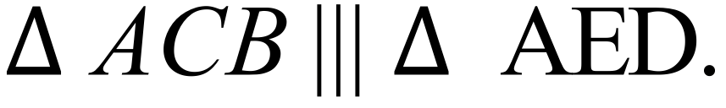  ……………………………………………………………………………………  ……………………………………………....……………………………………  ……………………………………………………………………………………  - Find the length of ED.  ……………………………………………….…………………………………  ……………………………………………….…………………………………… | 3  2
 | (c) In the diagram below, P is the centre of the smaller circle and Q is the centre of the larger circle.  A and B are the points of intersection of the two circles.  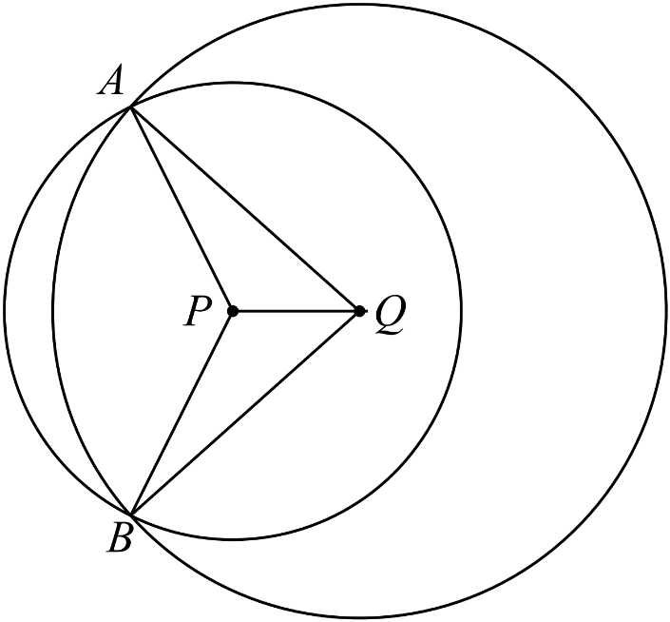  - Prove that  ……………………………………………………………………………………  ……………………………………………………………………………………  ……………………………………………....……………………………………  ……………………………………………………………………………………  ……………………………………………………………………………………  - What name best describes the type of quadrilateral for AQBP?  Give reasons for your choice.  ……………………………………………………………………………………  ……………………………………………....……………………………………  …………………………………………………………………………………… | 3  2

School Name
Mathematics Test 2017
Year 10 | Geometric Reasoning | Calculator Allowed  Longer Answer  Section
ANSWERS
Question | Answer | Marks
1. | (a)  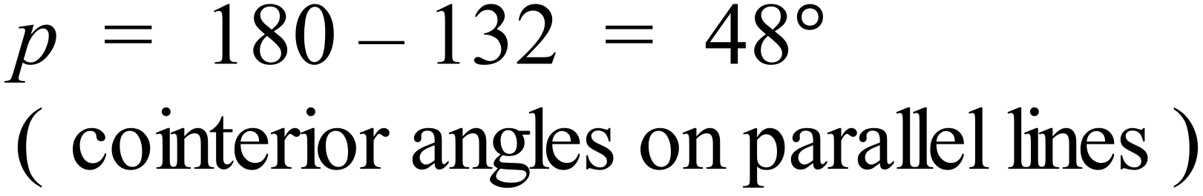 | 2 marks for correct answer with reason.  1 mark if answer or reason is wrong or not provided.
 | (b)  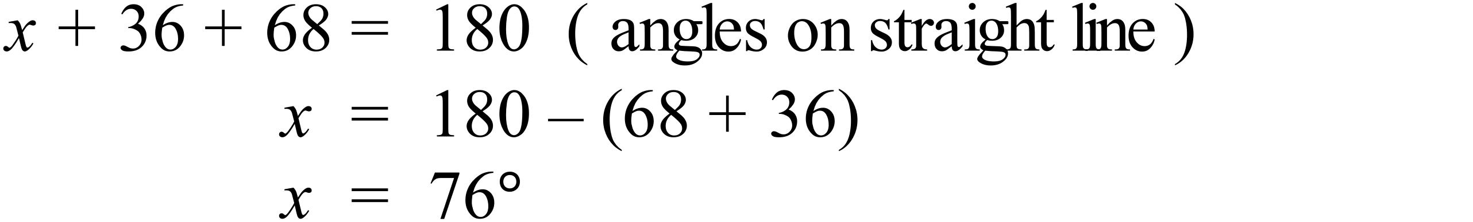 | 2 marks for correct answer with reason.  1 mark if answer or reason is wrong or not provided.
 | (c)  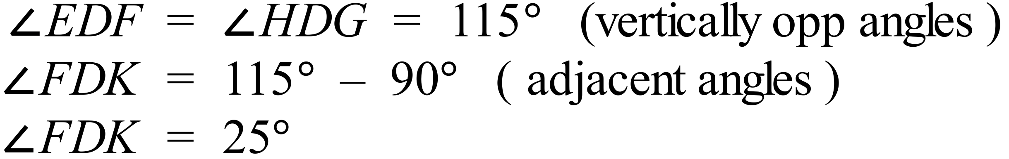 | 2 marks for correct answer with reason.  1 mark if answer or reason is wrong or not provided.
2. | (a)  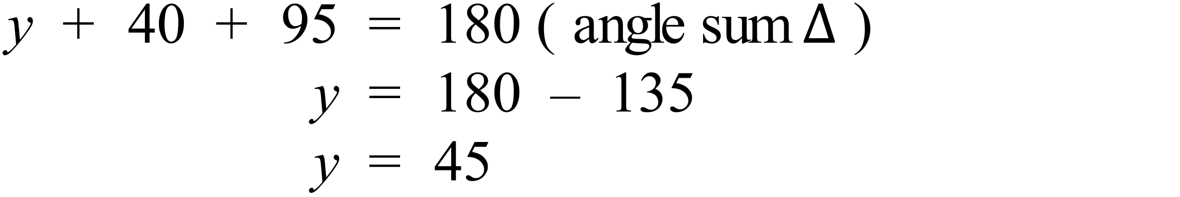 | 2 marks for correct answer with reason.  1 mark if answer or reason is wrong or not provided.
 | 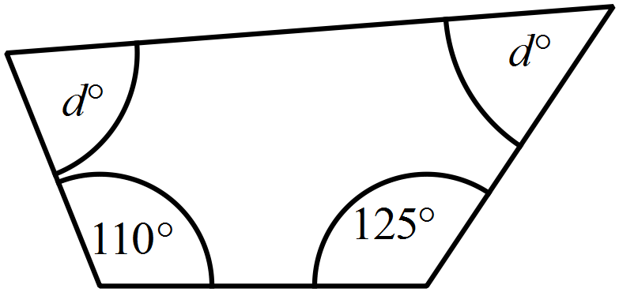(b)  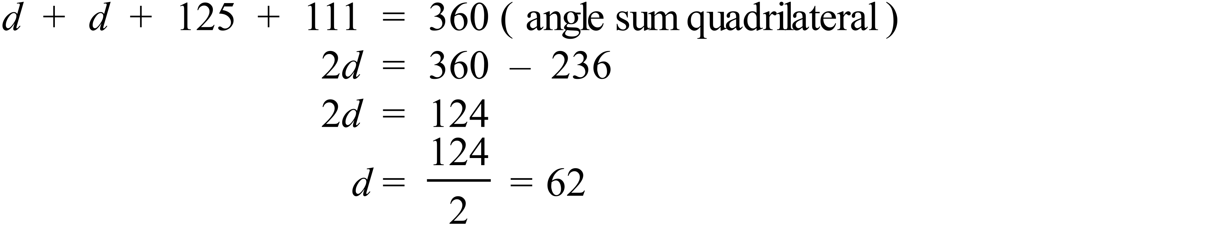 | 2 marks for correct answer with reason.  1 mark if answer or reason is wrong or not provided
 | (c)  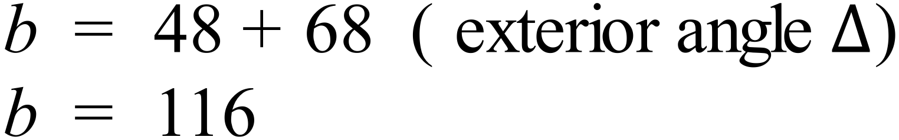 | 2 marks for correct answer with reasons.  1 mark if answer is calculated incorrectly or if reasoning is wrong or not provided
3. | (a)  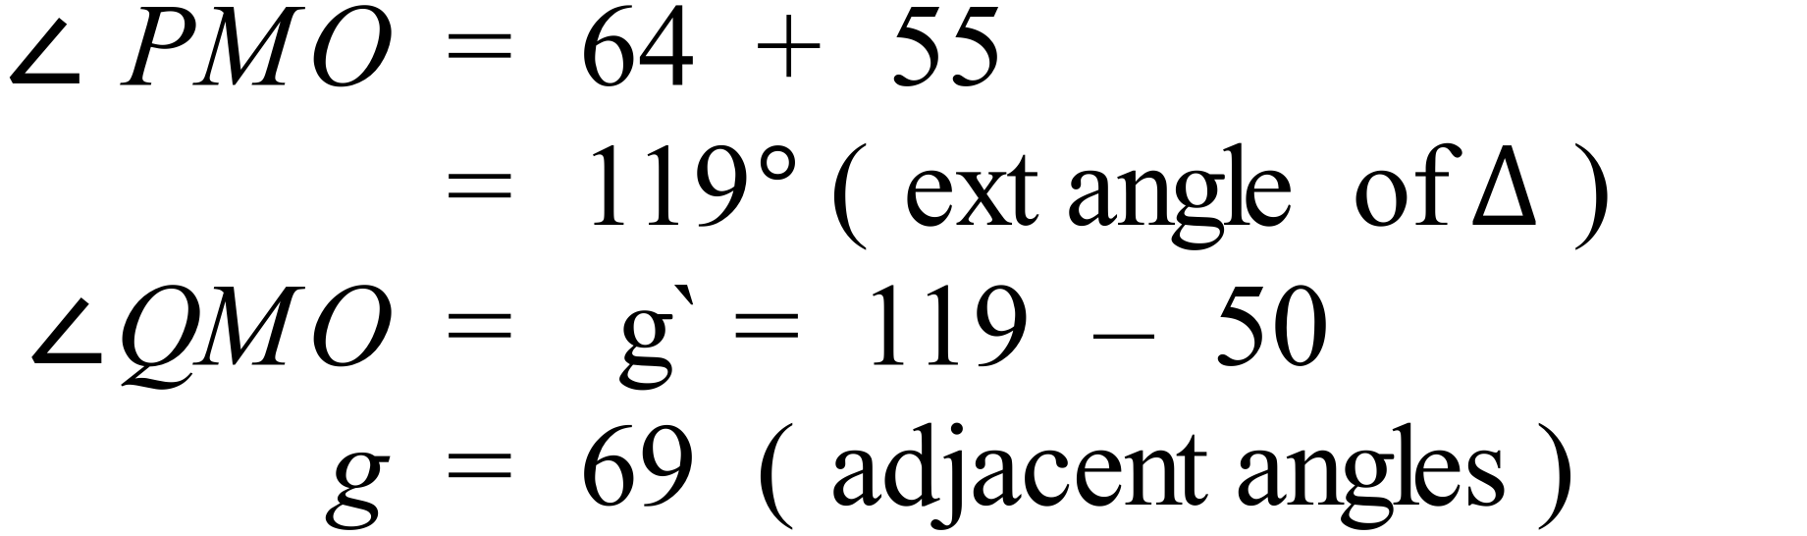 | 3 marks for correct answer with all reasons.  2 marks if answer is calculated incorrectly or one line of reasoning is wrong or not provided  1 mark for an answer that shows some correct reasoning.
 | (b)  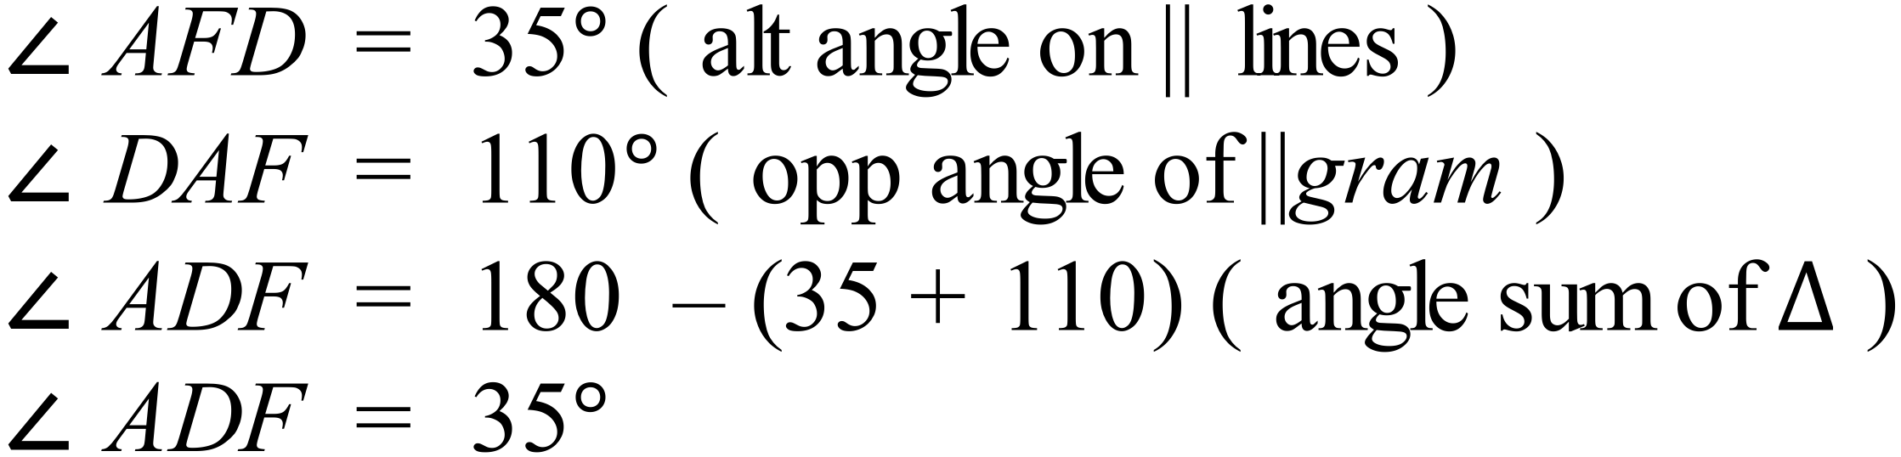 | 3 marks for correct answer with all reasons.  2 marks if answer is calculated incorrectly or one line of reasoning is wrong or not provided  1 mark if answer is calculated incorrectly and one line of reasoning is wrong or more than one line of reasoning is wrong or not provided
 | (c)  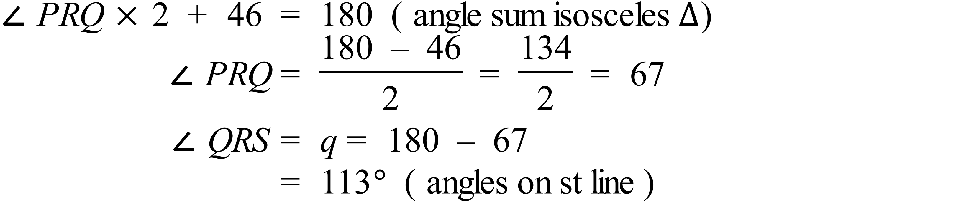 | 3 marks for correct answer with all reasons.  2 marks if answer is calculated incorrectly or one line of reasoning is wrong or not provided  1 mark if answer is calculated incorrectly and one line of reasoning is wrong or more than one line of reasoning is wrong or not provided
4. | (a)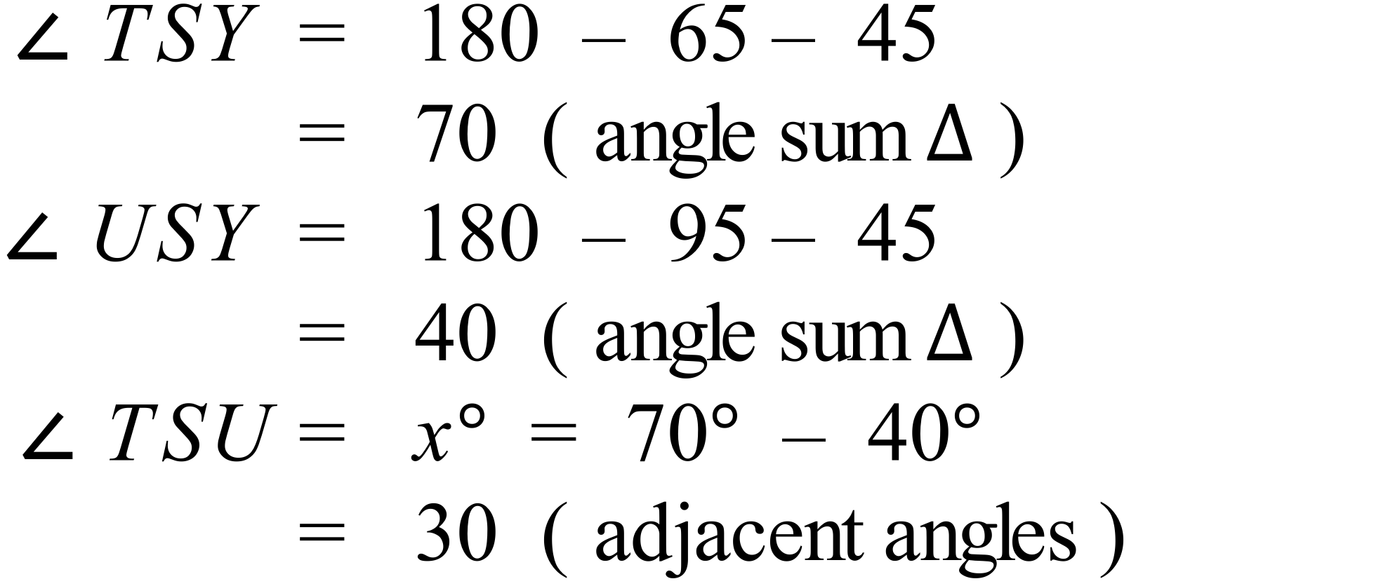 | 3 marks for correct answer with all reasons.  2 marks if answer is calculated incorrectly or one line of reasoning is wrong or not provided  1 mark if answer is calculated incorrectly and one line of reasoning is wrong or more than one line of reasoning is wrong or not provided
 | 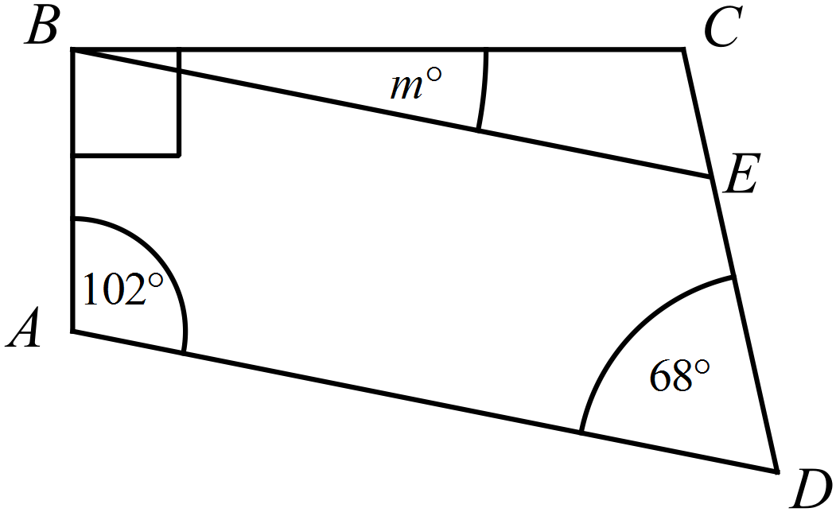(b) 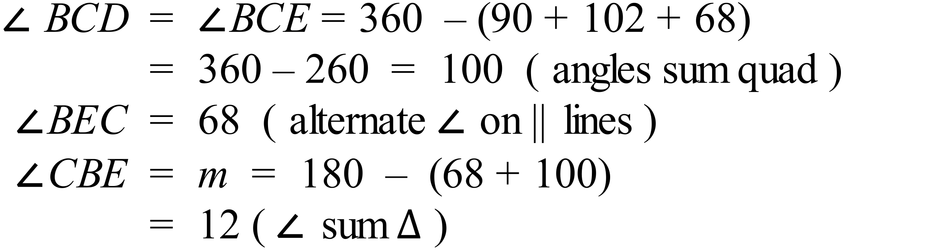 | 3 marks for correct answer with all reasons.  2 marks if answer is calculated incorrectly or one line of reasoning is wrong or not provided  1 mark if answer is calculated incorrectly and one line of reasoning is wrong or more than one line of reasoning is wrong or not provided
 | (c)  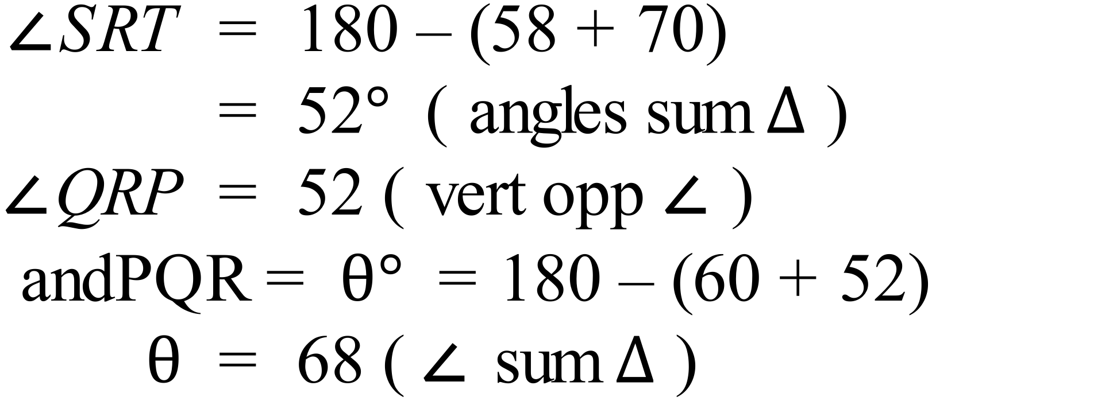 | 3 marks for correct answer with all reasons.  2 marks if answer is calculated incorrectly or one line of reasoning is wrong or not provided  1 mark if answer is calculated incorrectly and one line of reasoning is wrong or more than one line of reasoning is wrong or not provided
5. | (a)  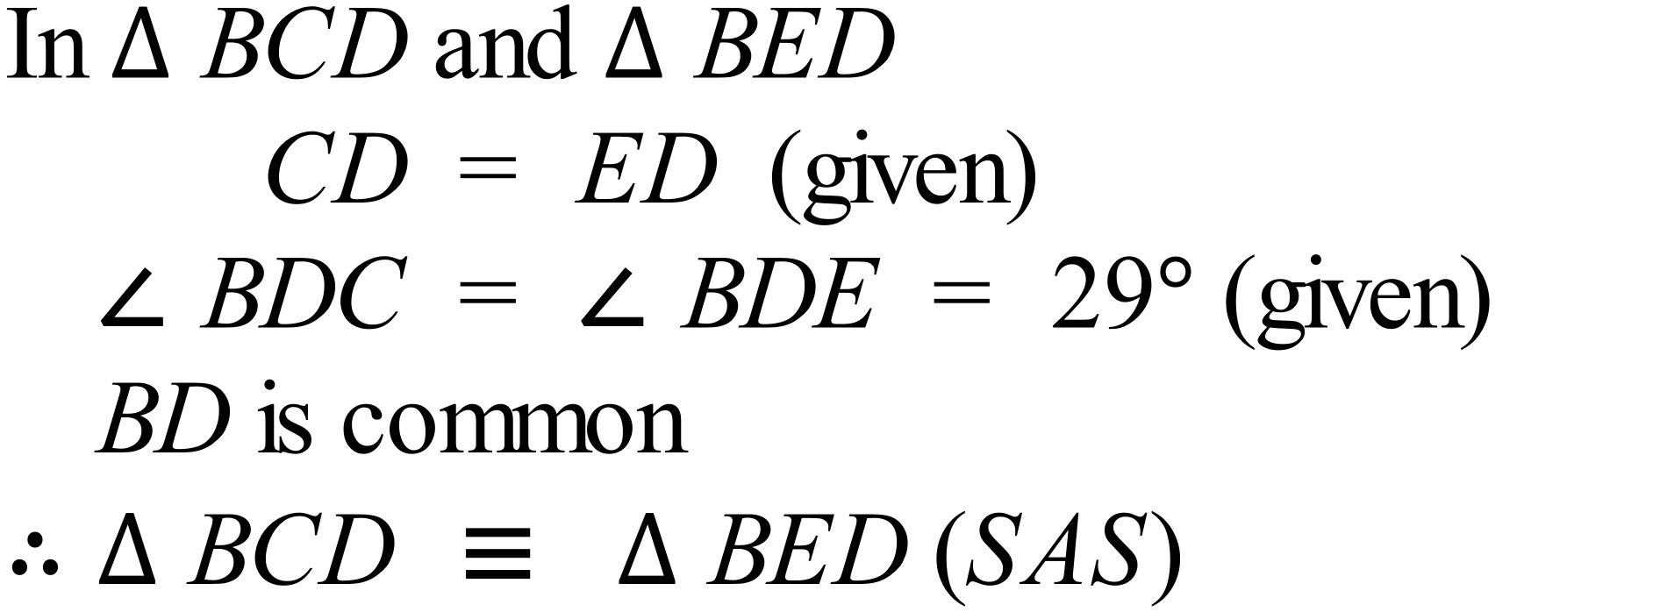 | 3 marks for correct conclusion with right congruence test and all steps of reasoning given.  2 marks for correct conclusion with one step of reasoning incorrect or not provided or if conclusion uses wrong test  1 mark if at least one correct statement needed for the proof is provided
 | (b)  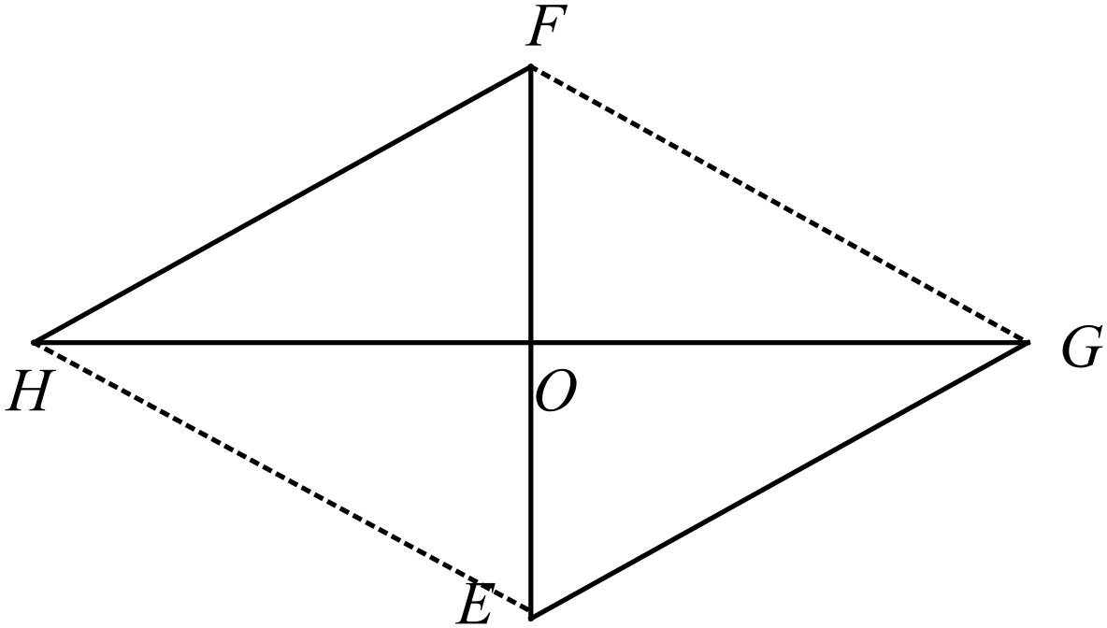  (i)  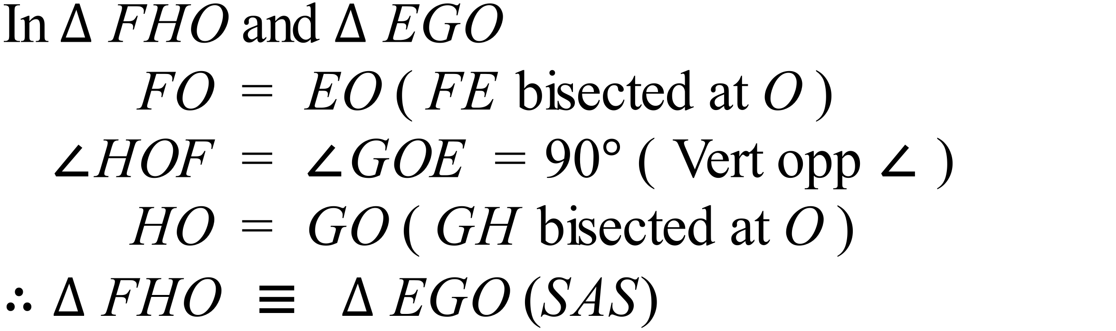  (ii) Other pairs include:  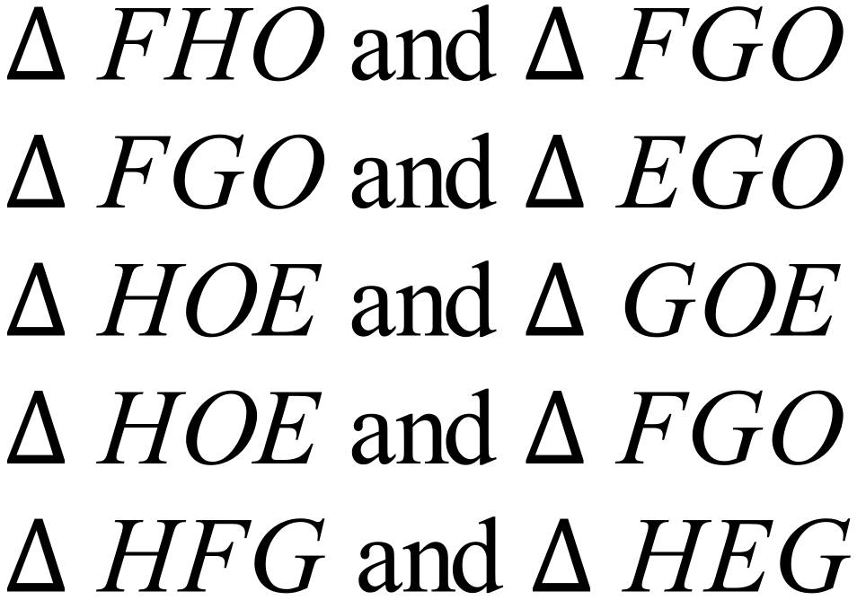  (iii) FGEH is a rhombus, as the diagonals bisect at right angles. (Or mention the congruent triangles giving all sides equal) | (i)  2 marks for correct conclusion with right congruence test and all steps of reasoning given.  1 mark for correct conclusion with one step of reasoning incorrect or not provided or if conclusion uses wrong test  (ii)  1 mark each for any two pairs  (iii)  1 mark for correct name and 1 mark for any valid reason
 | (c)  (i)  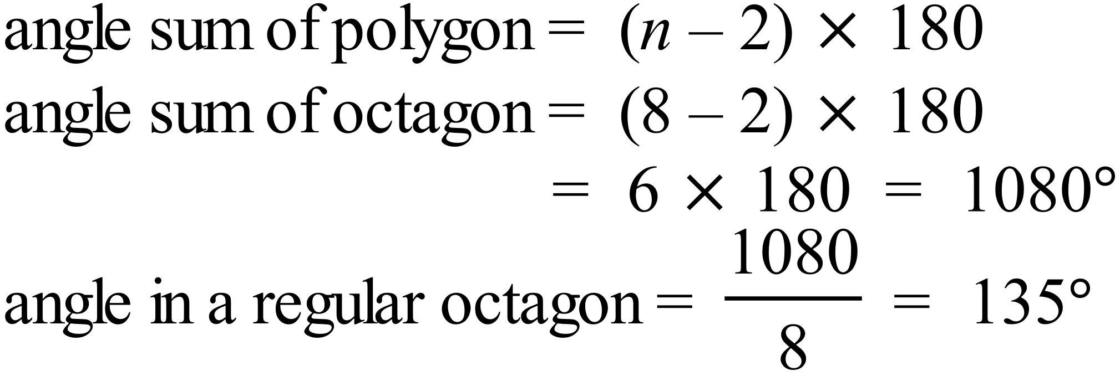  (ii)  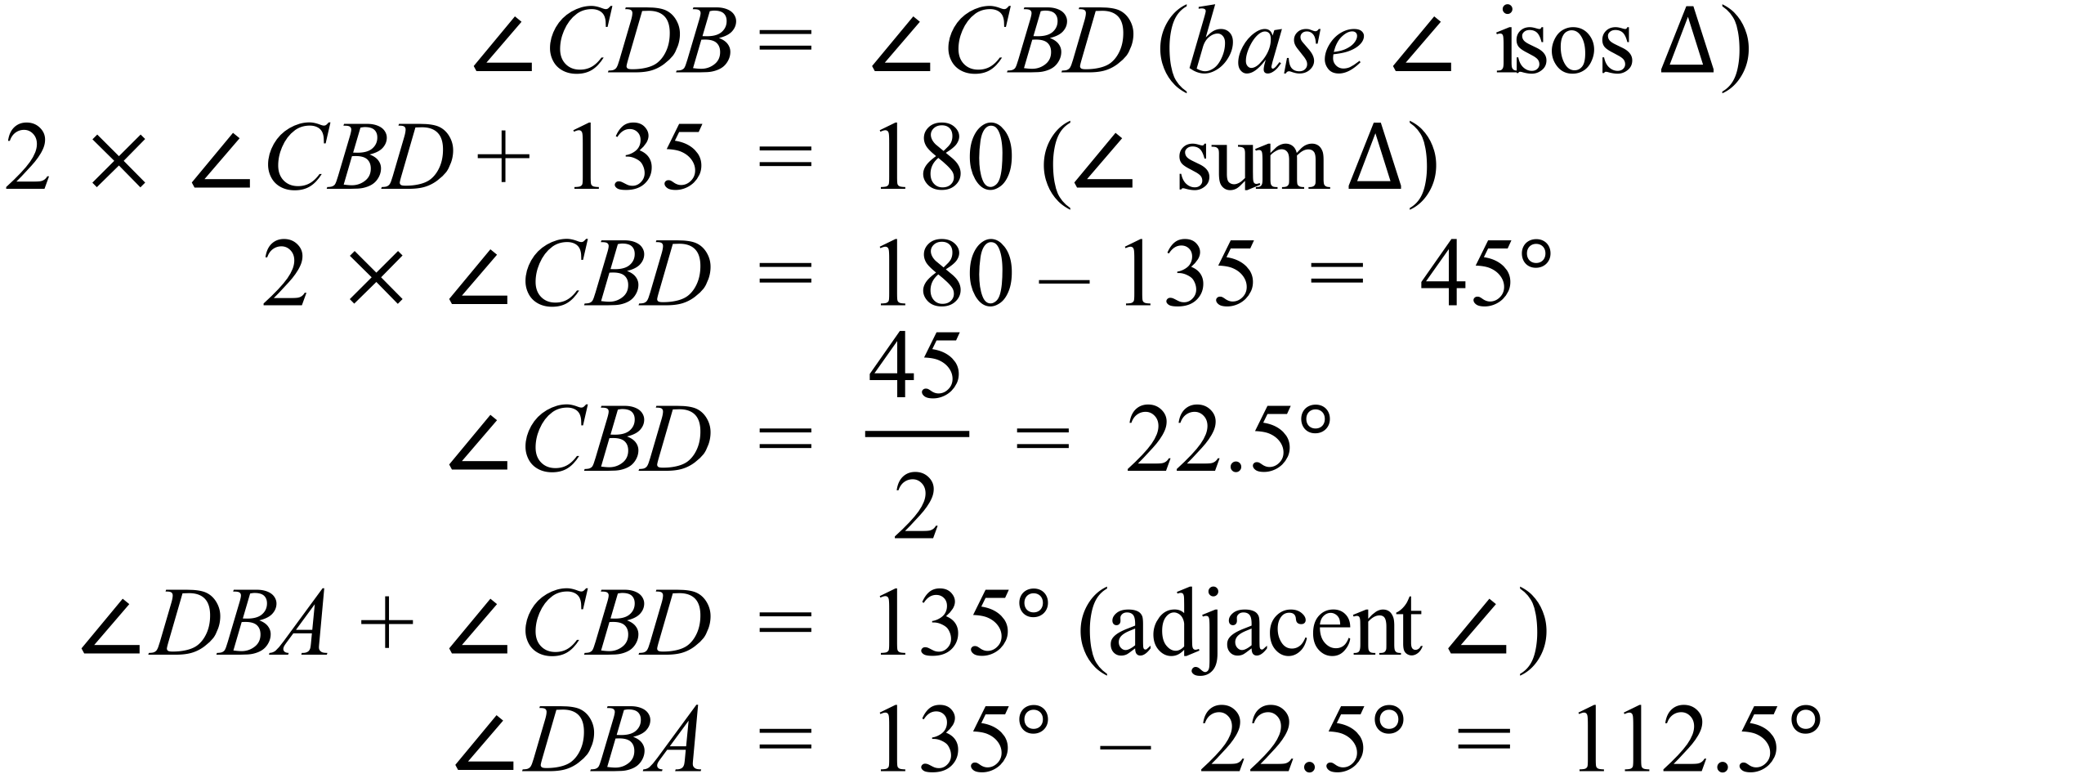  (iii)  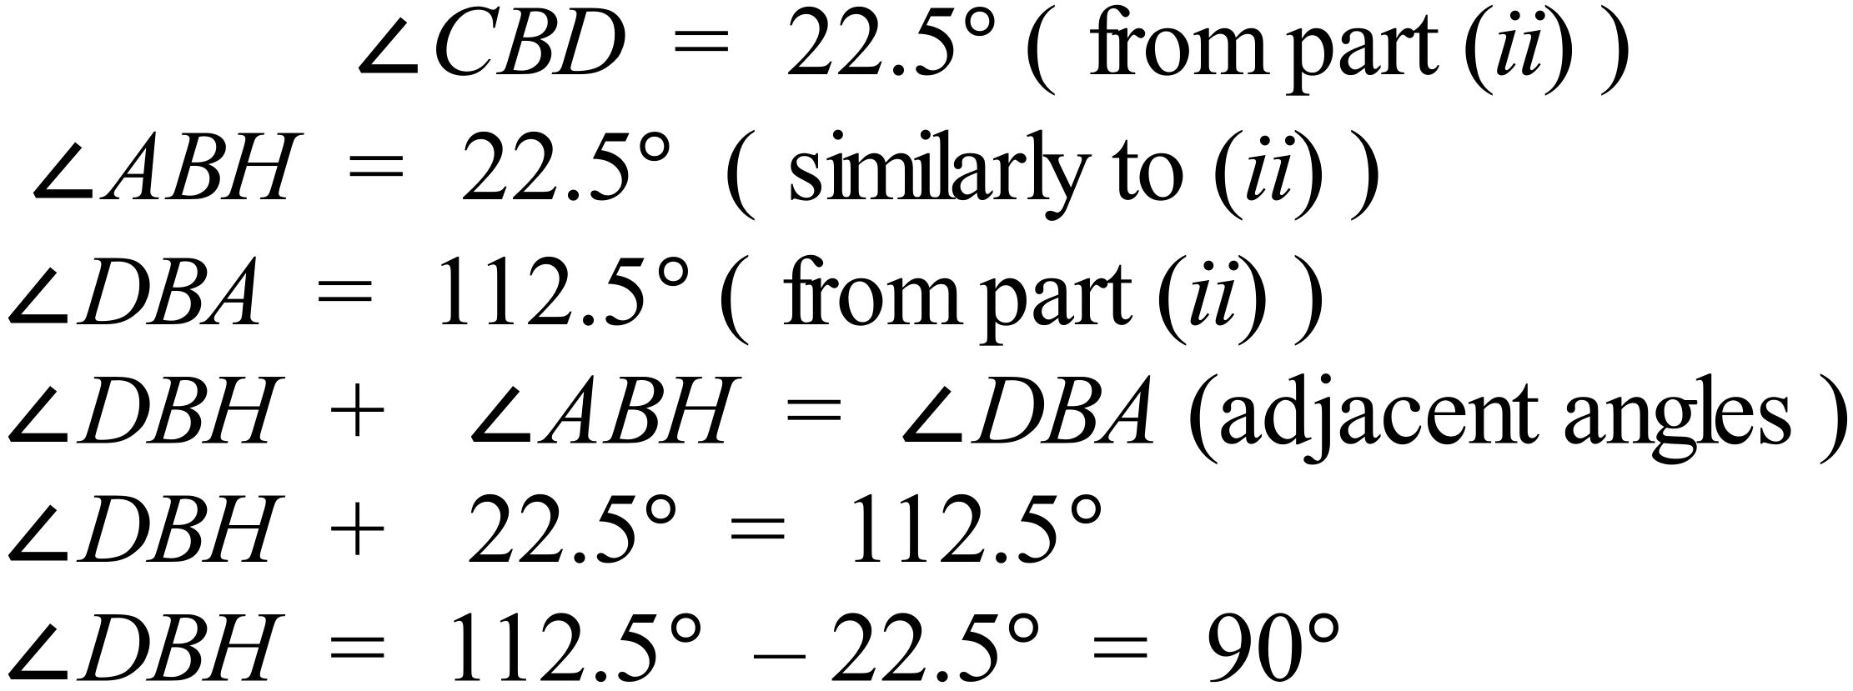 | (i)  2 marks for correct conclusion with right reasoning given.  1 mark for a minor error in reasoning.  ii)  2 marks for correct conclusion with right reasoning given.  1 mark for a minor error in reasoning.  iii)  2 marks for correct conclusion with right reasoning given.  1 mark for a minor error in reasoning.
6. | 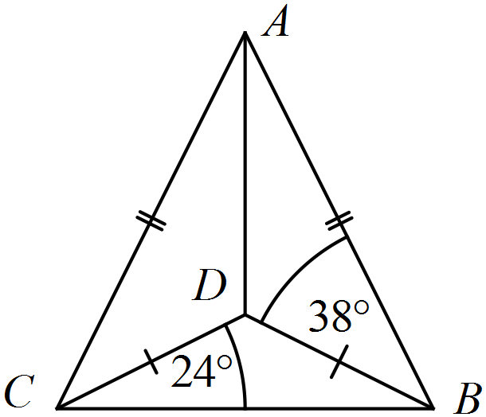(a)  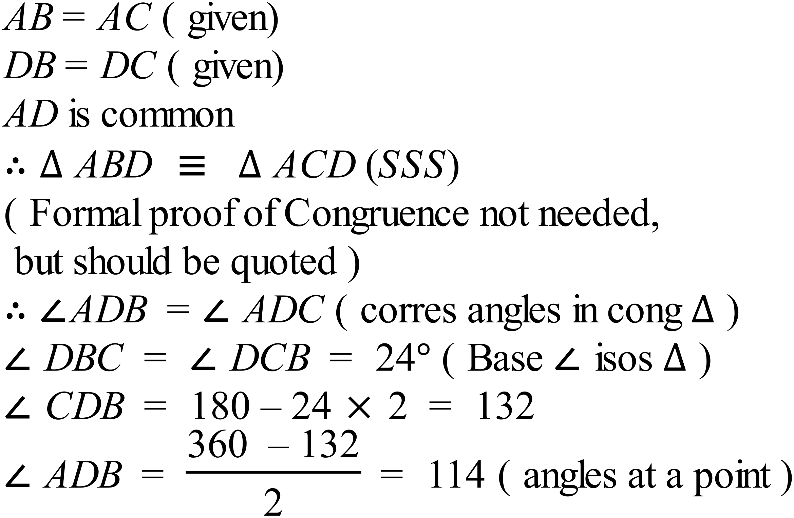  Alternative  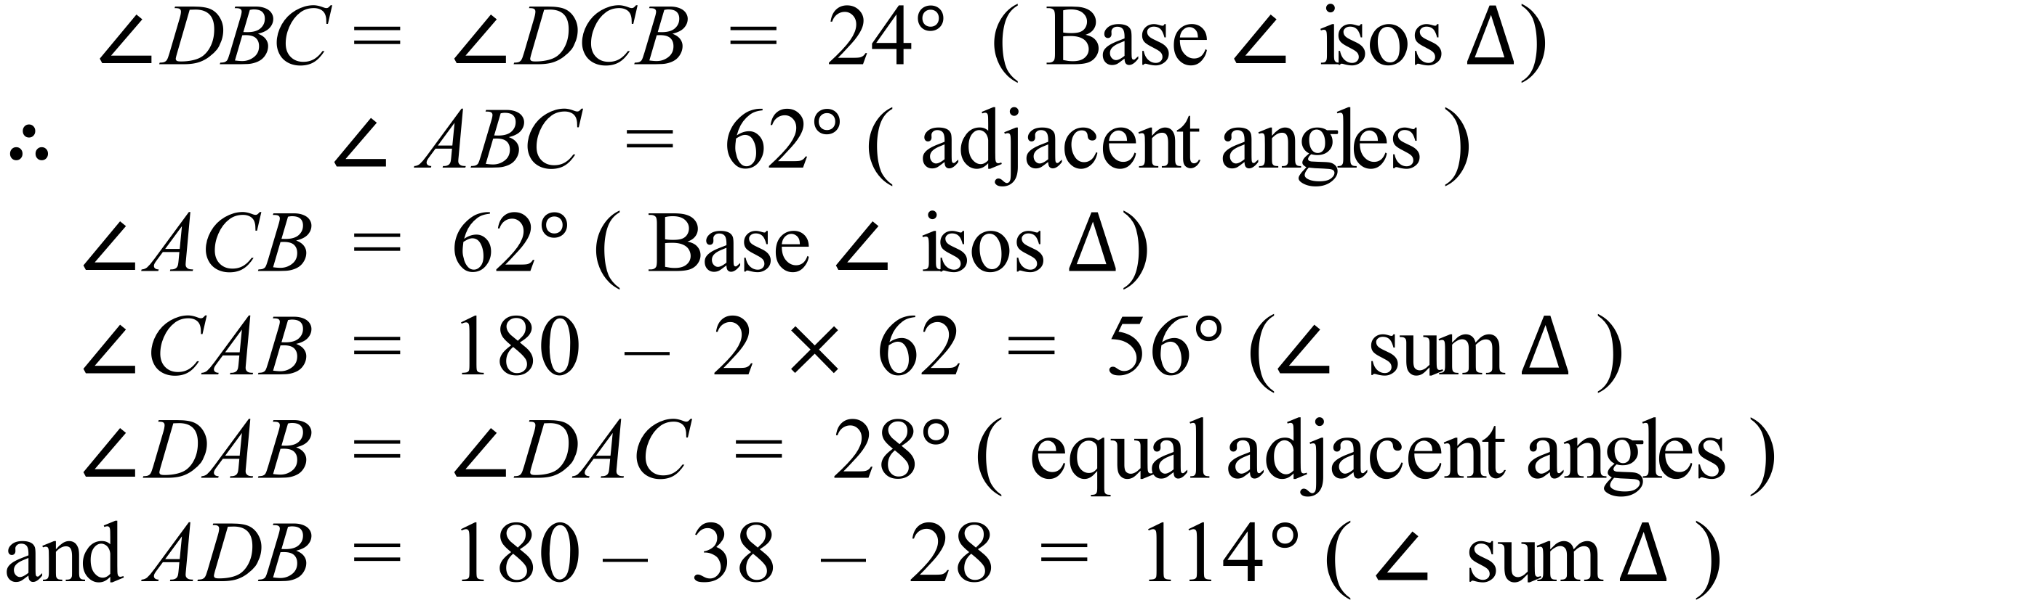 | 3 marks for correct answer with all reasons.  2 marks if answer is calculated incorrectly or one line of reasoning is wrong or not provided  1 mark if answer is calculated incorrectly and one line of reasoning is wrong or more than one line of reasoning is wrong or not provided
 | (b)  (i)  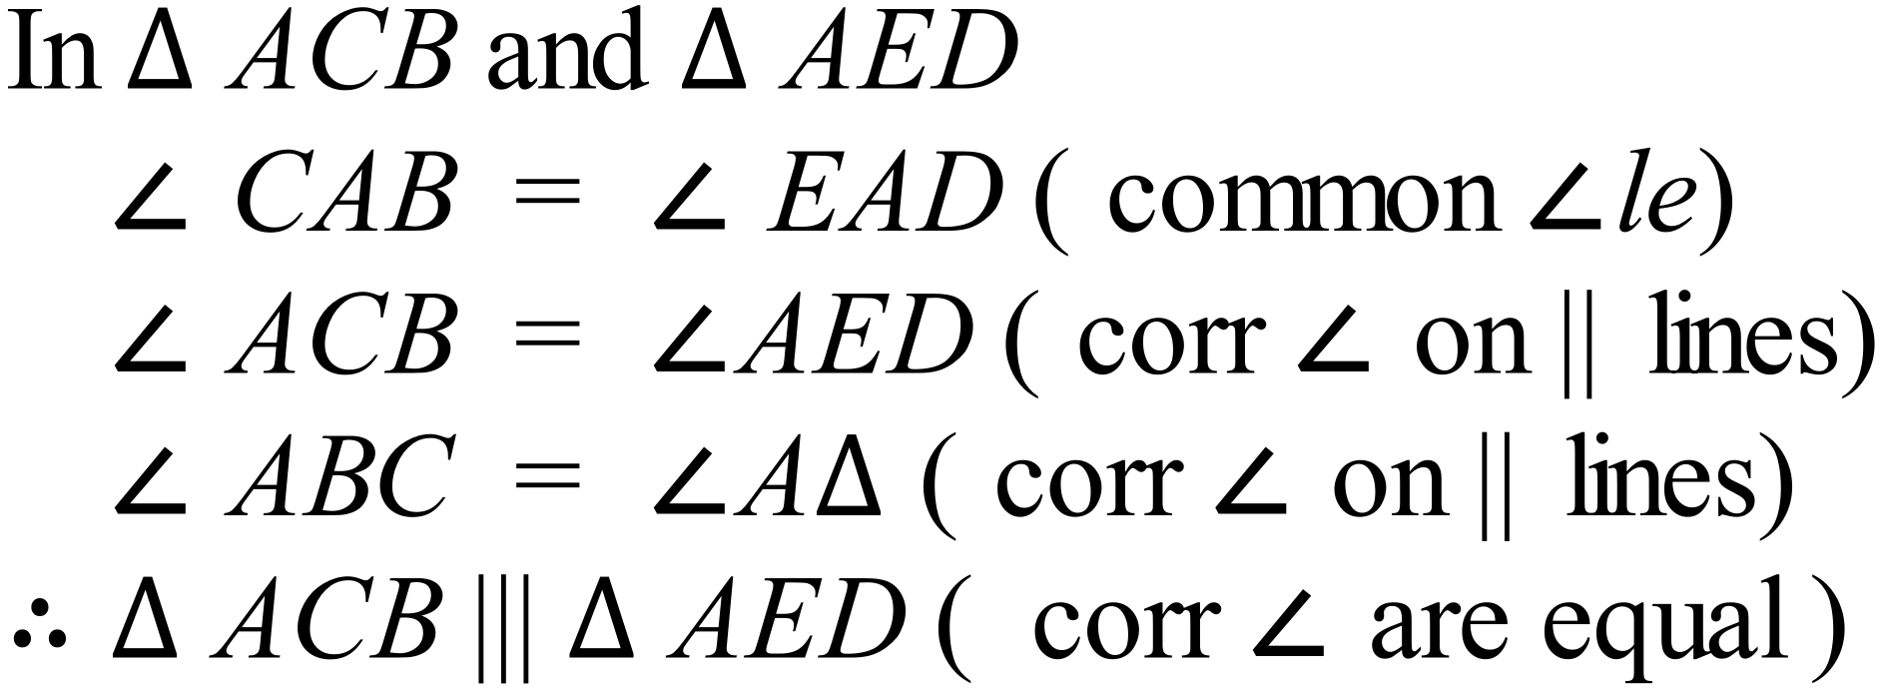  (ii)  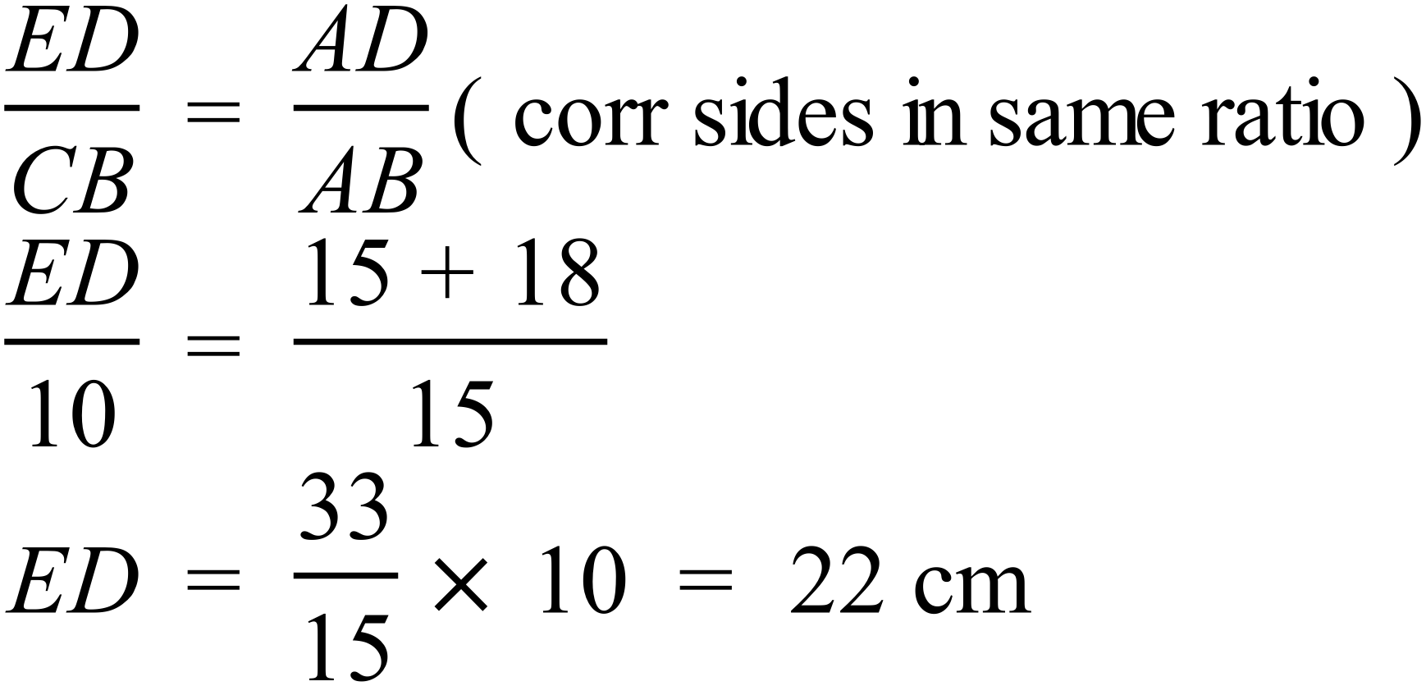 | (i)  3 marks for correct conclusion with right similarity test and all steps of reasoning given.  2 marks for correct conclusion with one step of reasoning incorrect or not provided or if congruence uses wrong test or conclusion is incorrect or not provided  1 mark if at least two correct statements needed for the proof are provided  (ii)  2 marks if answer is calculated correctly with reasoning/working provided  1 mark if answer is calculated incorrectly with some correct working/reasoning
 | (c)  (i)  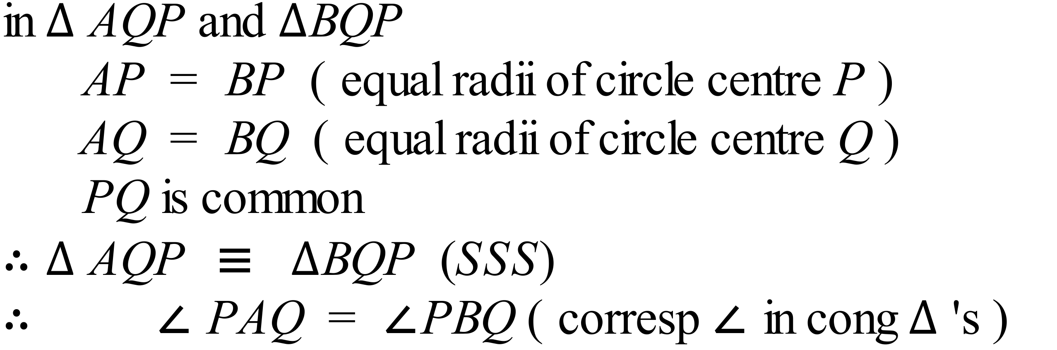  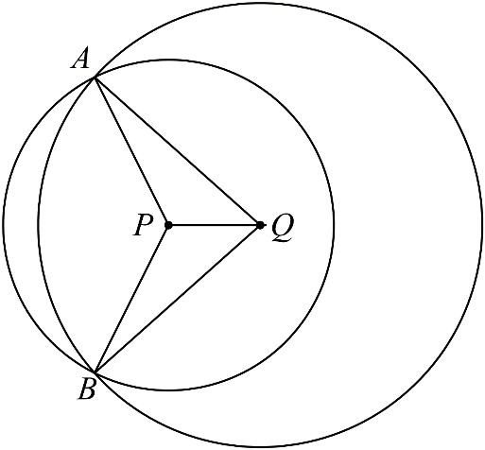  (ii) Quadrilateral AQBP is a kite.  Reason : There are two pairs of adjacent sides equal formed by the radii of the two circles. | (i)  3 marks for correct conclusion with right congruence test and all steps of reasoning given.  2 marks for correct conclusion with one step of reasoning incorrect or not provided or if conclusion uses wrong test  1 mark if at least one correct statement needed for the proof is provided  (ii)  1 mark each for name of quadrilateral and any valid reason which quotes a property unique to a kite.

